Fact Check
Future Fit Discounted options
Recently Dr Povey said that “the plan (proposed by Cllr Eade for a Specialist Emergency Hospital between Telford and Shrewsbury) had been looked at before Future Fit made its recommendations and that the new-build emergency centre (EC) was abandoned because it was a more expensive option.” Dr Povey reiterated the point by saying “A green field EC was considered early on and discounted, was a more expensive option.”
- The plan put forward by Cllr Eade has never been suggested by any working party nor considered by the Future Fit Board or by the CCG Boards or the SaTH Board.
The plan put forward by Cllr Eade looks like this:

Option | Long or Short list. Never considered by the FF Board. | PRH | RSH | Greenfield  Located off dual carriageway between Shrewsbury and Telford. | Community Hospitals. Intensive post Emergency Hospital discharge facility. | Hospital at home service.  Intensive post Emergency Hospital discharge service county wide.
Northumbria A |  | Diagnostic  Treatment  Centre + Planned  Surgery +  UCC | Hyper  Rehabilitation  Centre + Planned  Orthopaedic  Surgery +  UCC | Specialist  Emergency  Hospital +  UCC | Four locations as now. | County wide SaTH outreach service.
Northumbria B |  | Hyper  Rehabilitation  Centre + Planned  Orthopaedics +  UCC | Diagnostic  Treatment  Centre + Planned  Surgery +  UCC | Specialist  Emergency  Hospital +  UCC | Four locations as now. | County wide SaTH outreach service.

NB The model of service used in Northumbria is based on an integrated Health and Social Care model.
One “cog” in this model is the Specialist Emergency Hospital which depends very much on the other four “cogs” to enable a short, 36 hour length of stay service in the emergency phase of a patient’s unplanned episode of care.
Unfortunately the Future Fit Board, CCGs and the SaTH Board have not yet fully grasped the concept of what an integrated health service is or what one looks like.
The principle focus of these NHS organisations is and has been for the past four years, an obsession with hospital reconfiguration and not much else. Recently they have had some vague ideas about virtual beds, GPs taking on work currently done in hospital plus fanciful dreams about closing community hospital beds against a National policy backdrop of care closer to home.
The information below shows options as they developed during the Future Fit process.
There is absolutely no evidence whatsoever that the model of service which has been developed in Northumbria and includes a standalone specialist emergency hospital as part of an integrated health care system was ever presented to a consensus working party or considered by the Future Fit Board, the CCG Boards or the SaTH Board.
Initial options 2nd September 2014
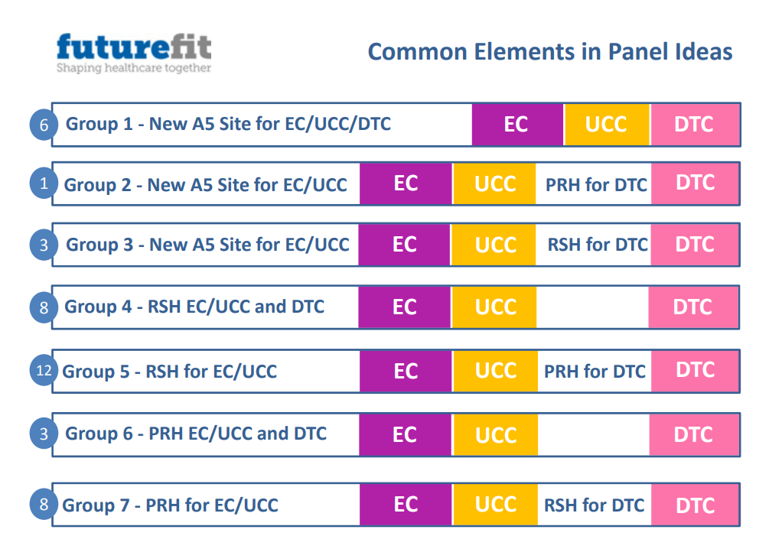

Source: http://nhsfuturefit.org/useful-documents/programme-information/option-appraisal/427-140902-evaluation-panel-v4/file
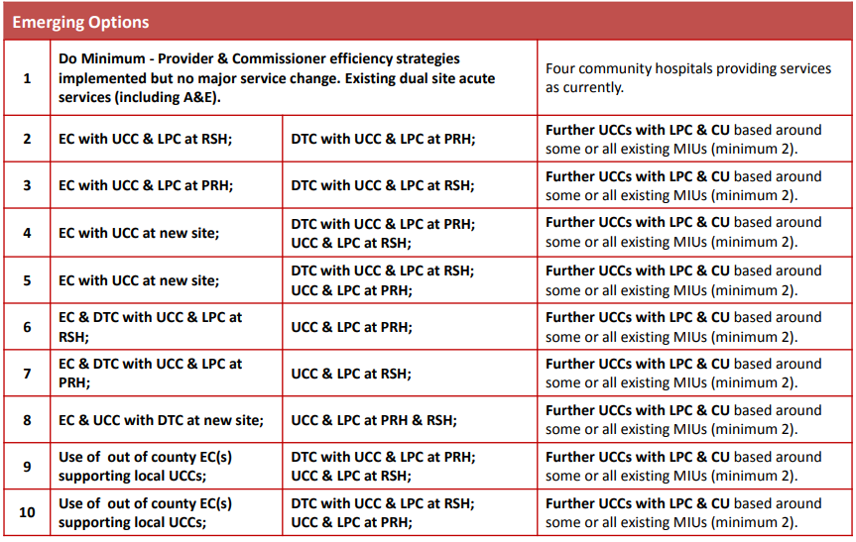
Source: http://nhsfuturefit.org/useful-documents/programme-information/option-appraisal/427-140902-evaluation-panel-v4/file

None of the option noted above in June / September 2014 resembles the Northumbria Specialist Emergency Hospital model as proposed by Cllr Eade.

Cont

Options 9th September 2014

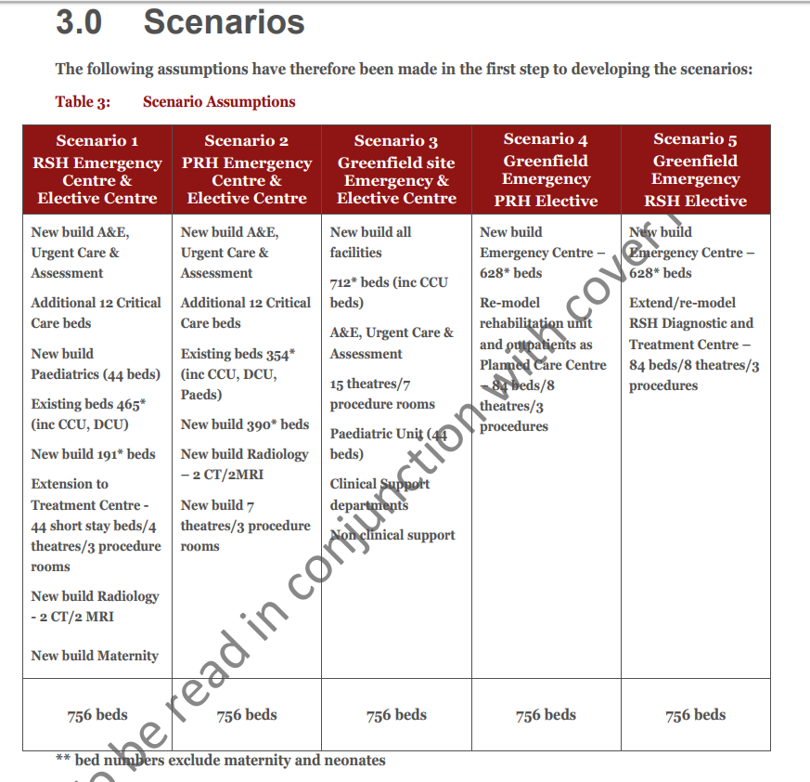
Source: http://nhsfuturefit.org/useful-documents/board-papers-and-update-reports/2014-3/17th-december-2014/347-feasibility-study/file
None of the option noted above in September 2014 resembles the Northumbria Specialist Emergency Hospital model as proposed by Cllr Eade.

Cont
Options 25th September 2014

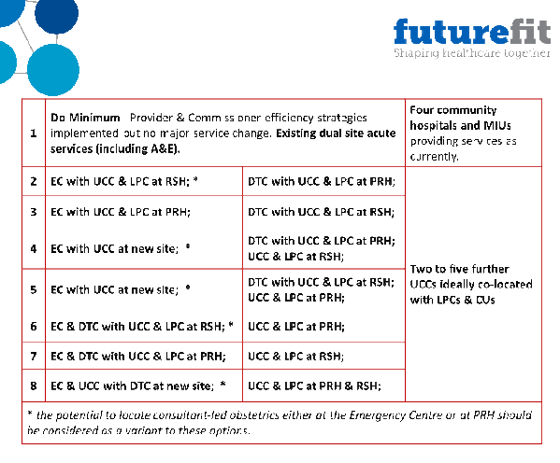
Source: https://www.sath.nhs.uk/wp-content/uploads/2016/09/140925-06-Future-Fit-Programme-Update.pdf
None of the option noted above in September 2014 resembles the Northumbria Specialist Emergency Hospital model as proposed by Cllr Eade.

Cont
Options 14th NOVEMBER 2014

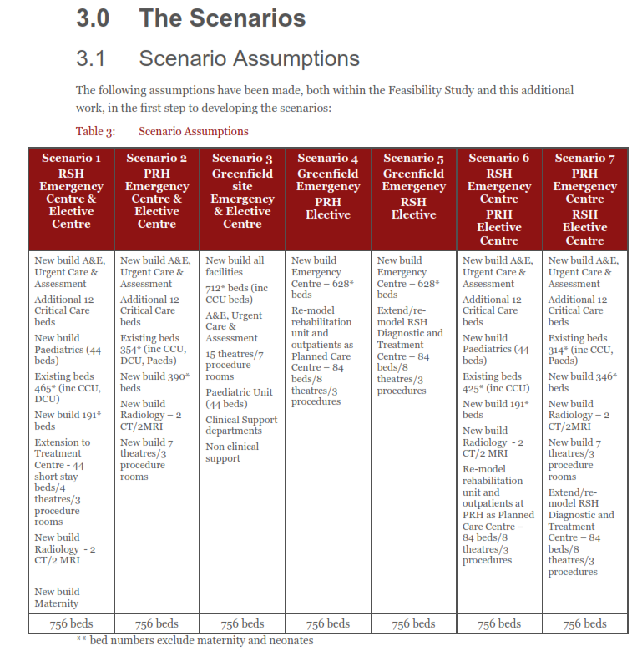

Cont
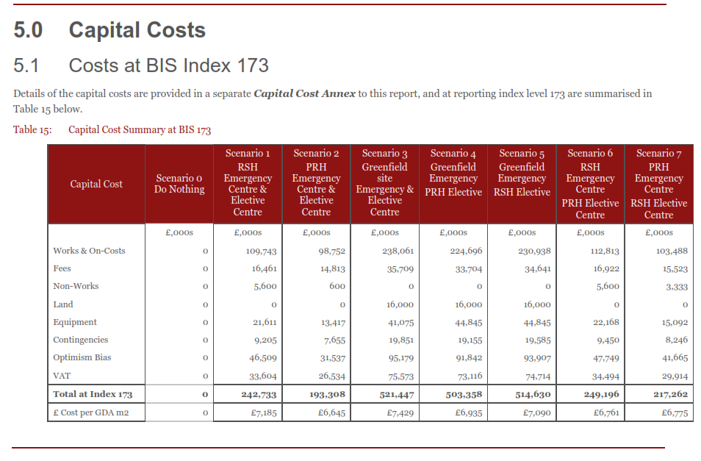
NB This document does not exist on the Future Fit web site. It is in my personal library. I am willing to share copies with people on request.
None of the option noted in November 2014 resembles the Northumbria Specialist Emergency Hospital model as proposed by Cllr Eade.

Cont
Options summary 13th August 2015

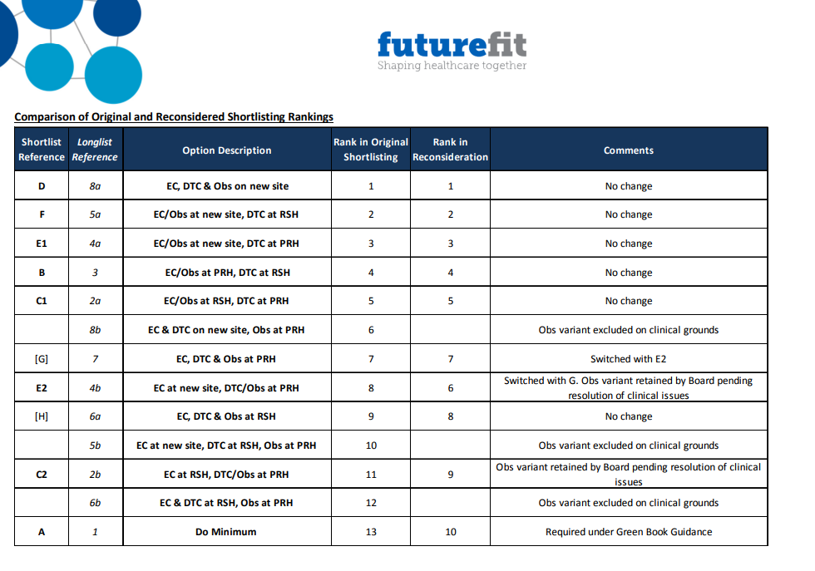
Source: http://nhsfuturefit.org/useful-documents/board-papers-and-update-reports/2015-3/13th-august-2016/390-150813-shortlist-update-v5-1/file
None of the options noted in 13th August 2015 summary of options resembles the Northumbria Specialist Emergency Hospital model as proposed by Cllr Eade.

Options 29th November 2016
DRAFT Outline Business Case Version 0. 9 for submission to SaTH Trust Board 29 November 2016
Development of the Options
The Outline Business Case has further developed three potential solutions, plus the ‘do nothing’:
▪ Do Nothing (Option A)
▪ Emergency Care at PRH and Planned Care at RSH (Option B)
▪ Emergency Care at RSH and Planned Care at PRH (Option C1)
▪ Emergency Care at RSH and Planned Care at PRH, with Women and Children’s retained at

Source: https://www.sath.nhs.uk/wp-content/uploads/2016/11/161129-SSP-OBC-v09-inc.-Appendices.pdf
None of the options noted in the SaTH Board papers 1st December 2015 resembles the Northumbria Specialist Emergency Hospital model as proposed by Cllr Eade.

Supplementary information
The service development process in Northumbria is still on going.
Significant numbers of bed closures have happened and are still a work
in progress.
The aim was to open the new 210 bed site then over a period of time lose about that number of beds from the rest of the system to be ' bed neutral ' overall. Not just by closures, but by a reconfiguration of
the two other main sites to improve the environment, make more flexible clinical space and more single rooms. Their plan was never just a quick 210 in so 210 else-where out tomorrow approach.
The hospital at Hexham was never earmarked for any closures, it is their ultimate super-efficient elective surgery factor, Hexham has been a popular choice for patients and for the last 5 years or so. This hospital has up to 50% of its patients who are from Cumbria - from both patient choice and also formal referrals as the Carlisle site has significant lack of capacity at present and for the foreseeable future.
The Trust closed over 60 beds on the Wansbeck site within a year of Cramlington opening, two porta-cabin complexes which had been thrown up shortly after that site opened because the PFI spec had been wrong. All now demolished for more car parking.
Both North Tyneside and Wansbeck moved from an average of 33 bedded wards to 28 , with the ability to flex up to 31 at times of pressure. Circa 80 fewer beds and overall better ward facilities.
So 140 gone from a start of around 1,100 - which included the 210 new beds at Cramlington. Which is more or less where the Trust planned to be at this stage.
The “wild card” they were not expecting was a 50% increase in Maternity deliveries - patient choice drawing mums who would have previously gone into Newcastle – they were expecting a small gain , but nothing like 50%.
This has given the Trust a problem at Cramlington both with bed numbers and configuration i.e. various issues around maternity and the needs of mothers. Sort this problem out has slowed some of the other planned changes in surgery but it is all on track and once they are through winter the work will continue.
Wansbeck is now majoring on elective orthopaedics, North Tyneside on General Surgery and a new super Endoscopy unit opened there last month.
The Trust knew that it was never going to be ' we have opened Cramlington lets shut loads of
beds tomorrow ', would be very simplistic to say the least. The Trust is running a programme of service reconfiguration and site realignment during which they need space for decanting areas to allow works to happen. The short term bed reduction has happened , the long term bed plan is in progress.
The Trust has overall circa 60 beds too many and are looking at ways to shrink the bed base further.
They have signed a Memorandum of Understanding with a Spanish organisation called RIBERIA SALAUD around their IT system and intellectual property associated with their way of working in order to become less bed dependent in Northumbria.

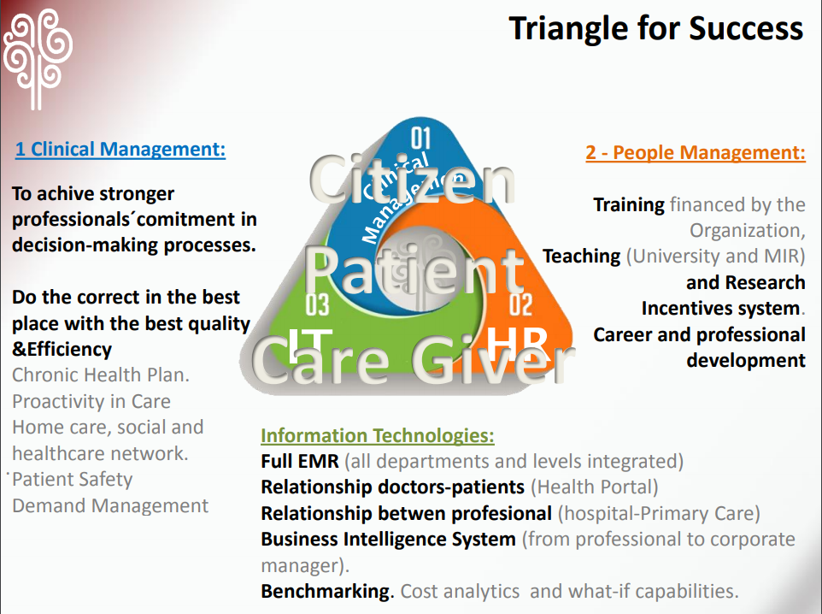 | 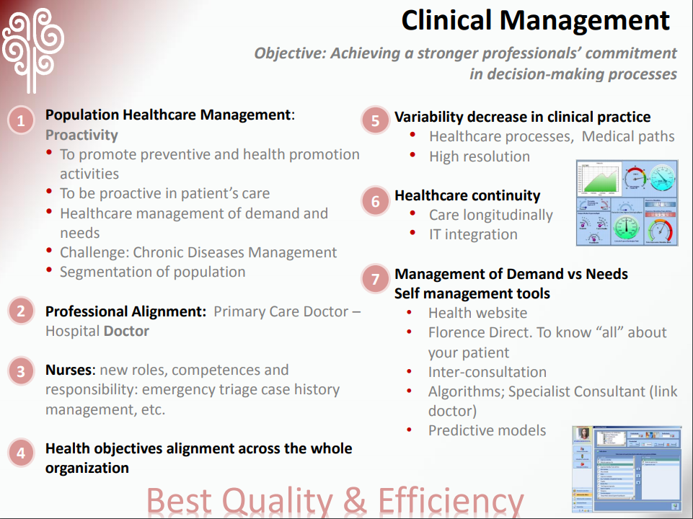
Source: http://www.nhsconfed.org/~/media/Confederation/Files/Publications/Documents/Information%20sharing%20for%20outcomes%20Alzira.pdf
The Trust is classed as Outstanding by the QCQ.
I believe one reason for this is because they have managed to bring consultants and GPs together in determining clinical policy they have a retired GP as a Non-Executive on the Board, a GP 50% as a medical director for the community business unit, six GPs who sit on the clinical policy group which meets one Friday each month and a joint clinical leads forum each month looking at clinical pathways.

Cont

Staffing
Shropshire Star report 24th January 2018:
“Writing on Twitter in response to the suggestion Mr Cheetham argued that the plan (for an emergency hospital between Telford and Shrewsbury) would not deal with staffing issues currently faced by hospitals in the county.”
There is some evidence to prove that a Northumbrian model of providing an integrated health care system would help Shropshire management to deal with difficult staffing issues and attract staff..

The A&E staffing levels at RSH & PRH are well known to be exceptionally poor and the 4 hour wait performance at SaTH is one of the worst in England.
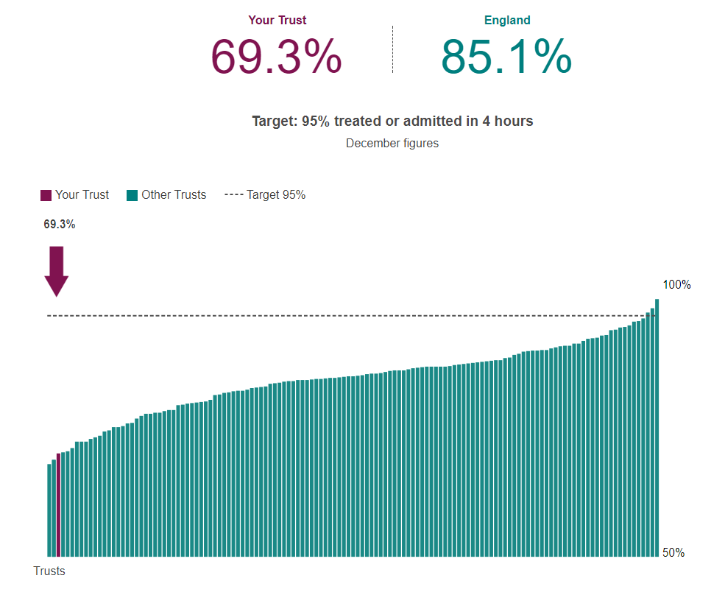

Data from a freedom of information request proves the A&E staffing is exceptionally poor at both RSH and PRH
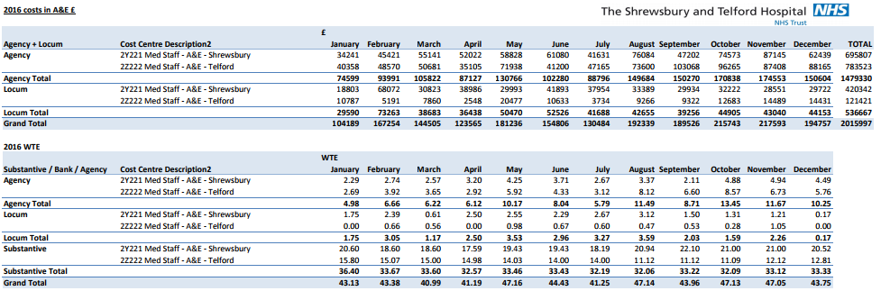
At the moment there are four Consultant posts available at the Northumbria Healthcare NHS FT.
In Shropshire the number of consultant posts needed in one department alone i.e. A&E is at least ten. At the moment there are five substantive A&E consultants and one locum covering A&E on two sites.
There are several Consultant posts in other departments at SaTH which are covered on the basis of long term locum consultant recruitment.
The Trust has failed to recruit Consultant Neurologists, they have two and need four. As a consequence the Trust has been forced into negotiating an arrangement whereby another hospital provides consultant cover on a hub and spoke basis.
On their visit to the Specialist Emergency Centre in Cramlington Northumberland Messer’s Pritchard, Eade, Dugmore and Sandbach were assured by the hospital Medical Director that medical staffing and staffing in general was not a significant problem and that the rotation arrangements for staffing the emergency hospital was seen in a positive light by their medical staff.
It is against the evidence presented above that people should judge the statement “that the plan (for a Specialist Emergency Hospital in Shropshire) would not deal with staffing issues currently faced by hospitals in the county.”
If Shropshire had a Specialist Emergency Hospital between Telford and Shrewsbury as part of an integrated health care system Mr Cheetham’s statement would only hold water if the SaTH management were totally and utterly incompetent and not fit to hold public office.
It is abundantly obvious the Trust in Northumberland has a grip on staffing issues; the Trust in Northumbria can deliver a seven day working system and staff the A&E Department / Hospital Emergency beds with appropriate clinical cover 24/7.
To suggest that this could not be the case here in Shropshire is difficult to make sense of or to accept as anything other than a weak argument against a progressive nationally acclaimed system of organising emergency health care in a large rural county similar to Shropshire.

David Sandbach
6th February 2018

https://www.shropshirestar.com/news/local-hubs/shrewsbury/2018/01/24/new-hospital-call-rejected-by-senior-health-figures/#izL5mUMlvUvX8x6T.99
https://www.sath.nhs.uk/wp-content/uploads/2016/08/Agency-Locum-Spend-in-AE.pdf
https://www.northumbria.nhs.uk/about-us/our-people/our-vacancies/medical-and-dental/
https://www.sath.nhs.uk/wp-content/uploads/2017/11/171130-11i-Emergency-Dept-Update-Actions.pdf page 9.

